Writing Center Slack Guide

We will be using Slack as the primary means of communication for us as a staff. We are using Slack for several reasons:
- As students, you receive a lot of email. Using a separate platform allows us to keep writing center communication separate, making it less likely to get lost in all the institutional communication you receive
- Slack is increasing being used as a communication platform within companies and industries, so you are gaining experience using this platform
- Slack offers a space for information and fun interactions meant solely to connect us and help us build community virtually.

App and Notification Preferences

Because Slack will be the primary mode of communication, I highly recommend downloading either the Slack desktop app onto your laptop or the mobile app on your phone (or do both!).

Additionally, you can set notification preferences of what kind of notifications you get, when you receive notifications, what kind of notifications receive, and how notifications work across the desktop and mobile app.
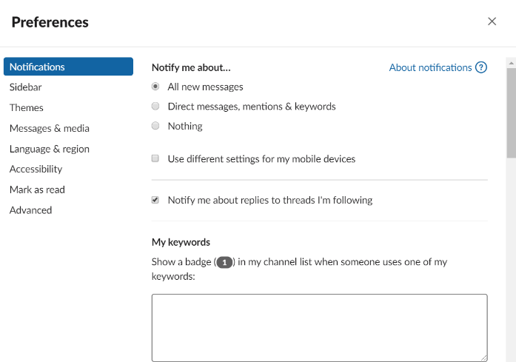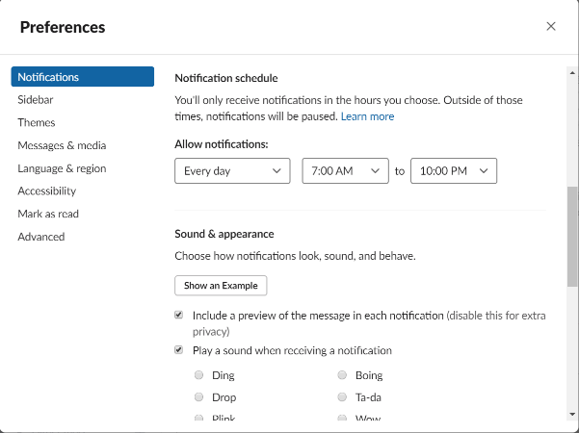
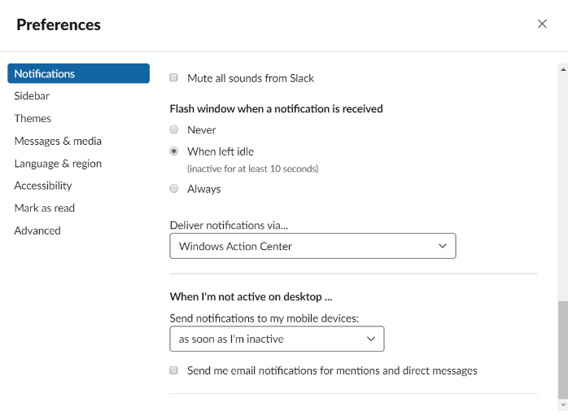
You can set the notifications as works best with your preferences, as long as it means that you see all relevant communication in a timely manner.
Channels

Slack organizes conversations by channel. Here are the channels that we will use and how each will be used:

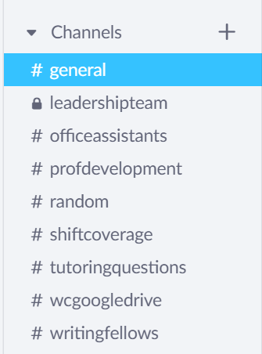
- #general: This is where I will share information and updates to the entire staff (including office assistants). Most posts in this channel will probably come from me, but if you have information that is relevant and you want to share with the whole staff, you can post it here, too.
- #leadershipteam: This channel will be used by any tutors serving in leadership roles. Tutors will need to be invited to participate in this channel.
- #officeassistants: This channel will be used for communication with the office assistants. Tutors will only be added to this channel if they are scheduled to do any hours covering the front desk.
- #profdevelopment: This channel will be used to post readings or resources you’ll be asked to review as part of ongoing professional development. When these materials are posted, you will be asked to post your thoughts and reflections on them in a threaded reply. Additionally, this is where I will post opportunities beyond our center (e.g. conferences, publication opportunities, jobs & internships, etc) that might be of interest to some of you. All tutors are encouraged to also post and share resources or opportunities that they think would be relevant to other writing tutors.
- #random: This channel will be devoted to non-work related conversations. Some of the conversations will be organized by the Team Building Coordinator(s) who will post weekly polls, contests, etc, but tutors are also encouraged to use this channel to connect with the community. Took an adorable picture of your dog? Post it. Got a great grade on a test you were worried about but studied really hard for? Tell us. Watched an amazing new series on Netflix you think some of would love? Share the recommendation. This is our space to bond and connect with each other even when we’re not physically together.
- #shiftcoverage: This channel should be used for requesting anyone to cover a shift you will need to miss. Refer to the shift coverage policy in this manual for more information for when you need to request shift coverage and when you need to message the director directly.
- #tutoringquestions: This channel is where you can pose any questions you have about tutoring, whether it’s about policies and procedures of our center, ideas about how to handle difficult tutoring situations or writing/composing related questions. While lead tutors will help field these questions as part of their responsibilities, all tutors are encouraged to answer questions or offer ideas.
- #wcgoogledrive: This channel is exclusively used to provide a quick link to materials in our Shared Google Drive that you can access directly from Slack. No conversations should happen in this channel to provide easy access to these materials.
- #writingfellow: This channel will be used for any tutors serving as writing fellows supporting specific classes in a given semester. Not only will it be for discussion amongst fellows, but faculty members with fellows will be given guest access to this channel to facilitate easy communication between faculty and fellow as well.
Directions for Posting and Replying

Slack includes a chronological list of posts and threads in each channel. To keep conversations organized, use threaded replies when responding directly to a message in a channel. You can also use @ to mention someone and include them in the conversation or you can add reactions to posts.
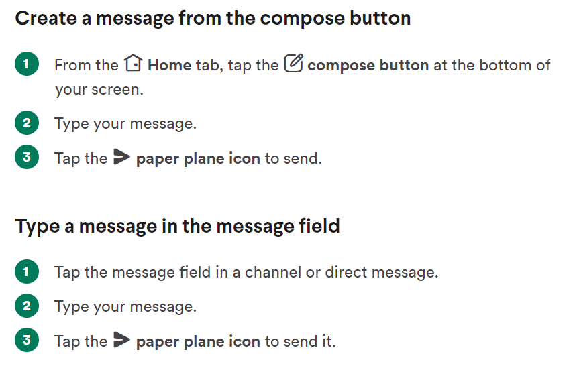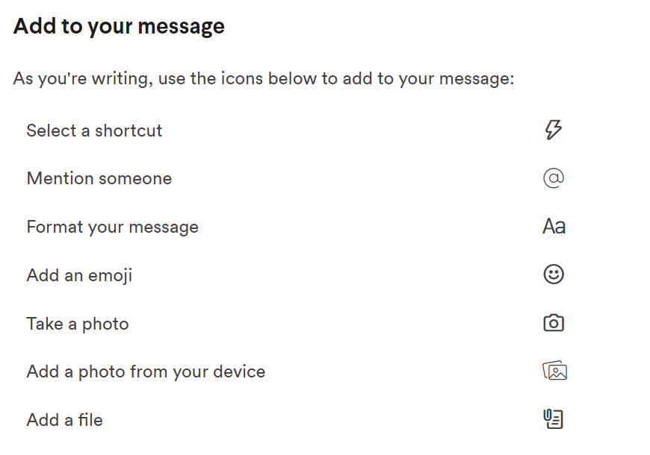
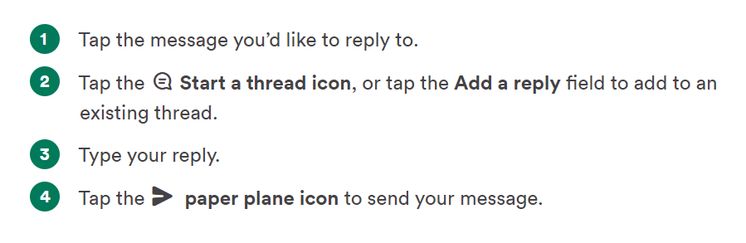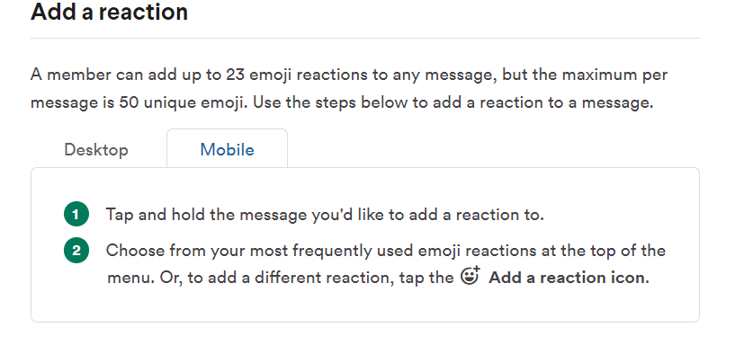

Customizing Slack

On Slack you can include a profile picture and update your display name. Under preferences, you can also update the theme/color of your slack app, how you want to view threads and unread messages, and even some options with emojis. You’re going to spend a lot of time on Slack, so take some time to figure out how to make it work best for you.

